Output w/ Annotations
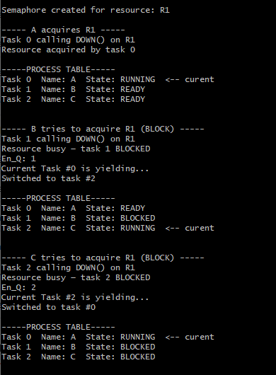

Here is our test output showing the yield() function of the scheduler. It should move to the next process in the process table and change its state to Running and the previous process’ state to Ready. It should also loop from the end of the process table back to the beginning. Based on the above output, that is what it is doing, so this test is a success.

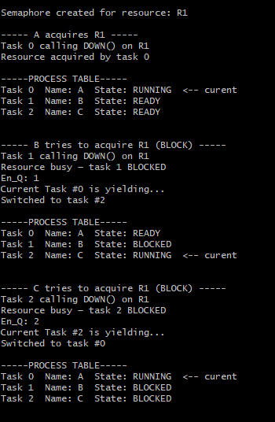
Here is the output showing each process trying to acquire R1. The expected output is for process A to successful acquire R1, and for B and C to be blocked trying to acquire R1 because it has not been released by A. The above output shows A acquiring R1 and B and C being blocked, so this test is a success.
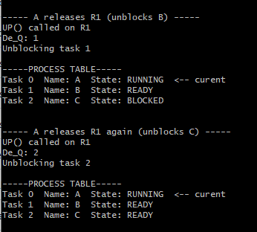
This output shows R1 being released by A and acquired by B, then released by B and acquired by C. This shows that the queue for acquiring R1 is working properly.

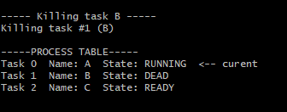
This output shows task B being destroyed, which will allow the garbage collector to free its memory.
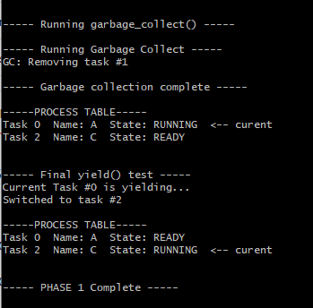
This output shows the garbage collection system freeing memory from dead tasks and removing them from the process table.

